PRESS RELEASE
No. 144/SP/TKP-ASEAN2023/8/2023
PUBLIC COMMUNICATIONS TEAM

FOR IMMEDIATE RELEASE

Russia, Important Trade Partner for ASEAN
Semarang, Kominfo Newsroom – Russia is an important trade and investment partner for ASEAN. It currently ranks ninth as an investor in the Southeast Asian region and holds the same position for trade balance.
This was a statement made by Minister of Trade Zulkifli Hasan, who also serves as Chair of the ASEAN Economic Ministers of 2023, during the opening of the consultative meeting between ASEAN Economic Ministers and Russia as part of the 55th ASEAN Economic Ministers’ Meeting (AEM) in Semarang, Central Java, on Monday (21 August 2023).
“Russia is an important trade partner for ASEAN. It is ranked ninth among the largest investors in ASEAN in 2022 among ASEAN’s dialogue partners,” said Zulkifli Hasan
He stated that the Southeast Asian bloc requires the support of Russia to strengthen its unity in facing global challenges in the future.
During the consultative meeting, the Russian delegation was led by Nikita Kondratyev, the Director-General of the Department of Multilateral Economic Cooperation and Special Projects at the Ministry of Economic Development of the Russian Federation.
In front of the Russian delegation, the Indonesian Minister of Trade explained that the role of ASEAN is highly significant and relevant because it serves as a hub of sustainable economic growth. Southeast Asia is also determined to create an architecture of inclusive economic growth.
“This meeting serves as an important momentum to strengthen economies of ASEAN and Russia,” said the minister.
Kondratyev outlined that the trade turnover between ASEAN and Russia has increased by 20%, reaching US$20 billion, the highest since 2014.
Meanwhile, the trade turnover between the United States and Russia increased by 3.6% in January – June 2023 compared to the first half of 2022.
Russia expressed its intention to strengthen its trade relationship with ASEAN. “We need to strengthen and expand our dialogue in several main areas that we should focus on, including maintaining stable supply chains and promoting sustainability,” said Kondratyev. (Indra Arief Pribadi/Kelik Dewanto/Elvira Inda Sari/Wisnu Wardoyo)
***
For more information, please contact:
Director General of Public Information and Communications of the Ministry of Communications and Informatics – Usman Kansong (0816785320).
Get more information at http://infopublik.id.
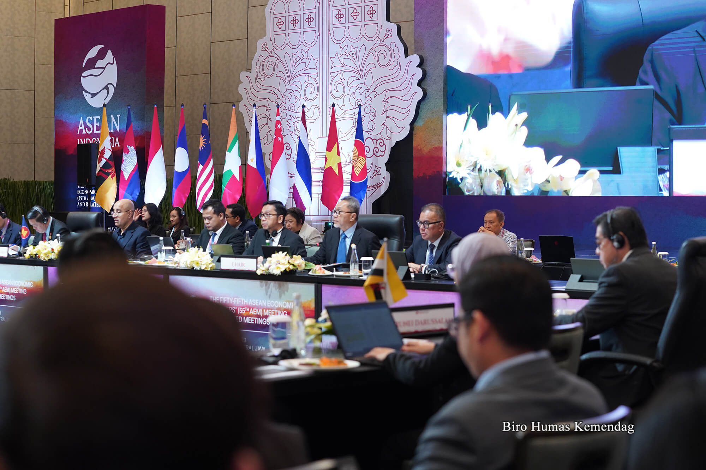
Indonesian Minister of Trade Zulkifli Hasan (center) serves as the AEM Chair during an AEM Meeting with the Director General of the World Intellectual Property Organization (WIPO) in Semarang, Central Java, on Sunday (20 August 2023).

